Experiment no.7 output

Query 7.1

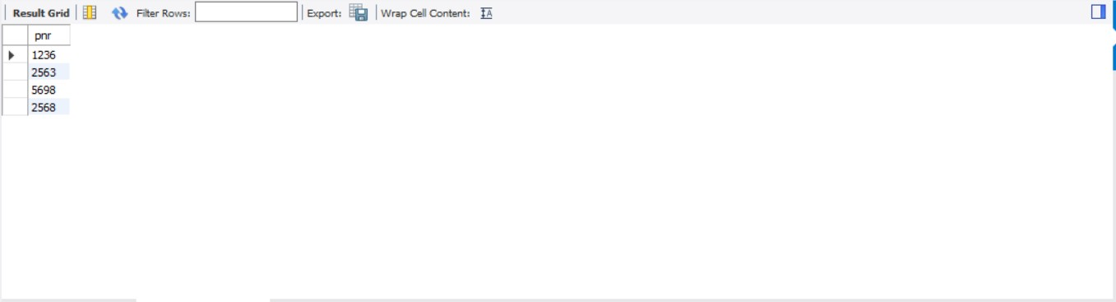

Query 7.2

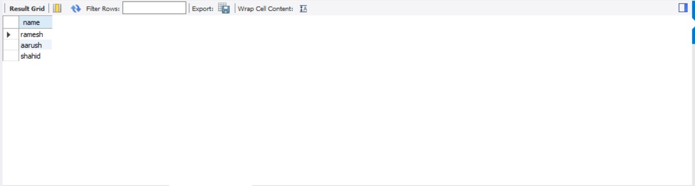

Query 7.3

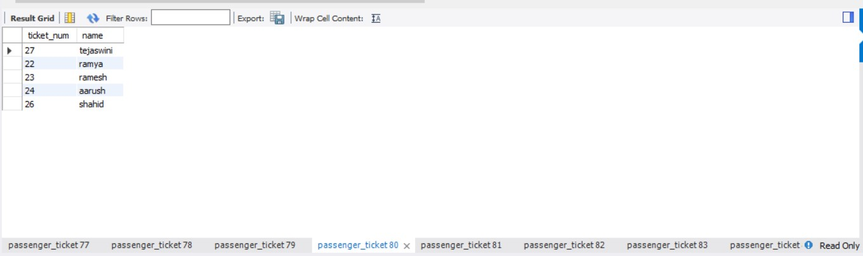

Query 7.4

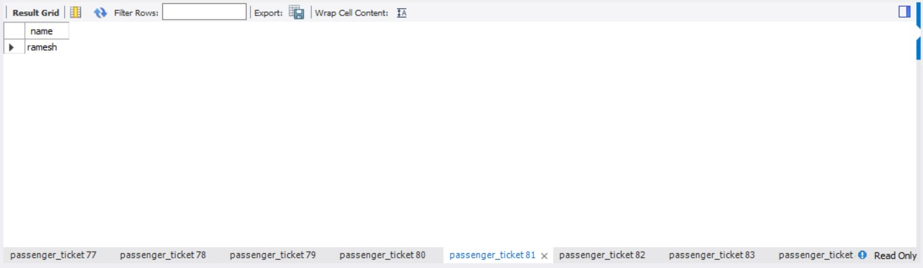

Query 7.5

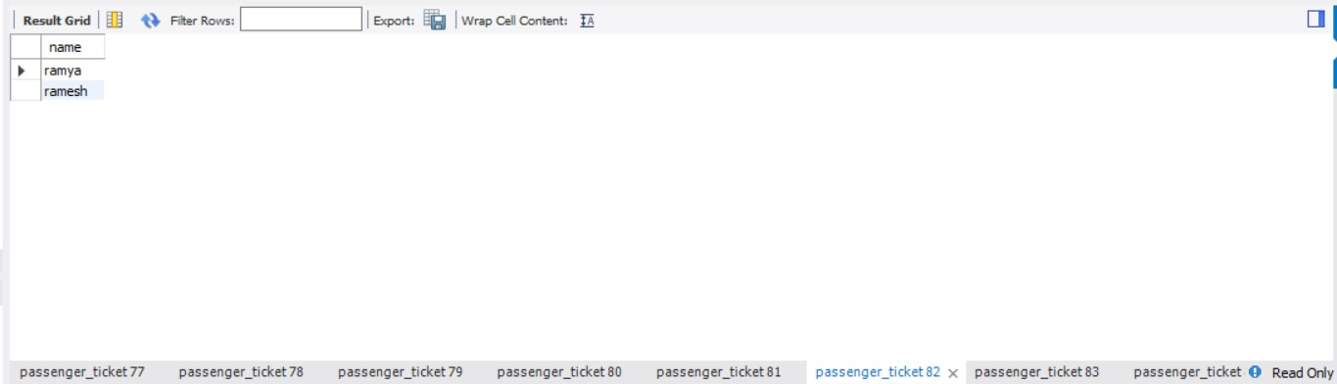

Query 7.6

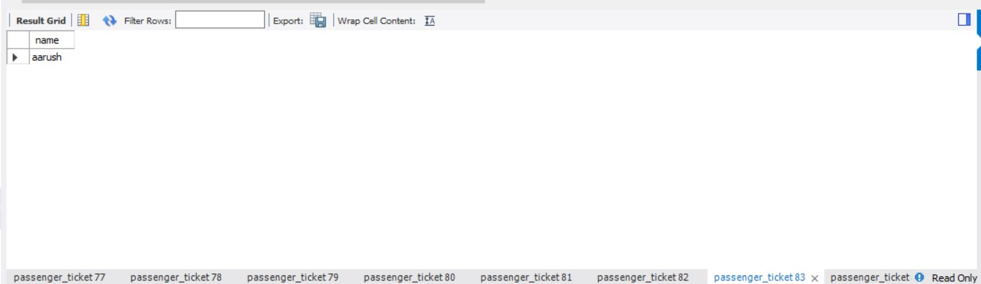

Query 7.7

